Modifying your Windows XP Boot logo
DISCLAIMER: We here at The Tech Guide are NOT responsible for anything that happens to your computer as a result of this procedure. DO THIS AT YOUR OWN RISK!
This procedure is very similar to modifying the Windows 2000 boot logo (full tutorial on that located at Little White Dog). Microsoft decided to remove the pallet from the logo to another location. So now when you open up ntoskrnl.exe in Resource Hacker, the .bmps are just black images. For those of you who have no idea what I am talking about, don't worry.
The first tool you will need is Resource Hacker. First locate your ntoskrnl.exe, which can be found in \windows\system32. Make a copy of your ntoskrnl.exe and rename ntoskrnl.bak. Now fire up Resource Hacker and open the ntoskrnl.exe.
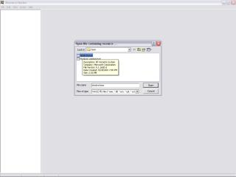
In the left hand column you will see a list of resources to edit. Open the first tree called Bitmaps and you will see numbers 1-10. Numbers 1, 8, and 10 are the WinXP Pro bitmaps. 1, 7, and 9 are for Home Edition. In this tutorial we will be using Pro. Select number 1.
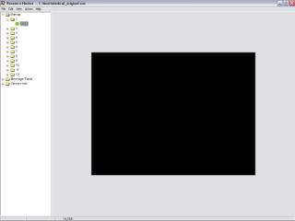
Then go to the action menu and click 'save Bitmap'.
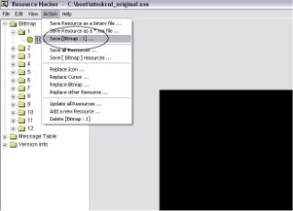
Save the bitmaps wherever you would like to, just remember where they are for later use. Repeat the process for numbers 8 and 10. Now for editing these images, we will be using Jasc Paint Shop Pro 7. Open all three of these images into Paintshop. When they open, they will be completely black. In order to see the real images, we have to import the pallet. Here is the palette for Paint Shop Pro: 16.pal. And one for Photoshop: 16.act (you may need to right-click the links and select save-as to have your browser save the files instead of trying to display them). In Paintshop, hit Shift + O and select the 16.pal file.
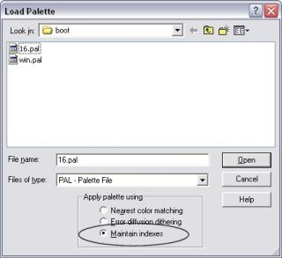
Make sure to select 'Maintain Indexes'. If you open all three images at once, you will need to apply the palette for each of the images. The images should now be visible.
Number 1 should look like this:
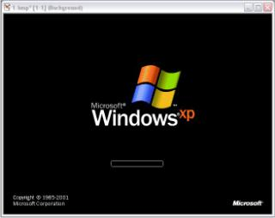
8 like this:

And 10 like this:
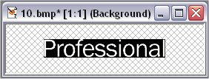
After you are all finished editing the logo, save them. Open Resource Hacker again, and open the ntoskrnl.exe. Go to 'Action/Replace Bitmap...
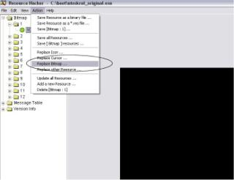
Select Bitmap to replace for 1, then click on 'Open file with new Bitmap' and locate your edited boot logo. Then click replace. Follow the same steps with 8 and 10. Once you are finished with that, go to Save As and save your new ntoskrnl.exe to a directory other then the system32 directory (so it doesn't overwrite the original). Now because of Windows File Protection, you will need to reboot into safe mode (reboot, hit F8 before the boot srceen comes up) or boot off a DOS bootdisk (check out www.bootdisk.com for floppy boot images) to overwrite the original ntoskrnl.exe. Once you have done either of those, reboot, and that should do it.
Note: It can be done with Adobe Photoshop, and I assume other image editing programs that support palette importing. However, I have only tried it with Paint Shop Pro and Photoshop.
This was put together pretty fast, so there will be more updates on it (i.e. other program support, some sample boot logos, etc.).
- By Barret and OpenFriday

