The Sharpe Ratio
The Sharpe Ratio actually helps you find the best possible proportion of these securities to use, in a portfolio that can also contain cash.
The definition of the Sharpe Ratio is:
S(x) = ( r_{x} - R_{f} ) / StdDev(x)
where
x is some investment
r_{x} is the average annual rate of return of x
R_{f} is the best available rate of return of a "risk-free" security (i.e. cash)
StdDev(x) is the standard deviation of r_{x}
The Sharpe Ratio is a direct measure of reward-to-risk. To see how it helps you in creating a portfolio, consider the diagram of the efficient frontier again, this time with cash drawn in.
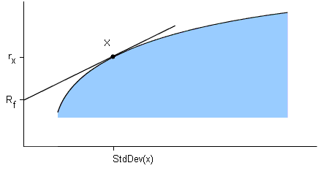
There are three important things to notice in this diagram:
- If you take some investment like "x" and combine it with cash, the resulting portfolio will lie somewhere along the straight line joining cash with x. (This time it's a straight line, not a curve; cash is riskless, so there's no "damping out" effect between cash and x.)
- Since you want the rate of return to be as great as possible, you want to select the x that gives you the line with the greatest possible slope (like we have done in the diagram).
- The slope of this line is equal to the Sharpe Ratio of x.
Putting this all together gives you the method for finding the best possible portfolio from this collection of securities: First, find the investment with the highest possible Sharpe Ratio (this part requires a computer); Next, take whatever linear combination of this investment and cash will give you your desired value for standard deviation. The result will be the portfolio with the greatest possible rate of return.

Treynor Ratio
Like the Sharpe Ratio, the Treynor Ratio (sometimes called Reward-to-Variability-Ratio) also relates excess return to risk; but systematic risk instead of total risk is used. The higher the Treynor Ratio, the better the performance under analysis.
T = {r - rf} / b
T... Treynor ratio
r... Portfolio return
rf... Riskfree rate
b... Portfolio beta
In mean/beta-space, the Treynor Ratio is graphically represented by the line between the riskfree rate and the portfolio.
Like the Sharpe Ratio, T does not quantify the value added of active portfolio management. It is a ranking criterion only. But it can be expected that portfolio managers which possess private information will have a higher T than the T of the uninformed market strategy. A ranking of portfolios based on the T measure is only useful if the funds under consideration are sub-funds of a broader, fully diversified portfolio. If this is not the case, portfolios with identical systematic risk, but different total risk, will be rated the same. But the portfolio with a higher total risk is less diversified and therefore has a higher unsystematic risk which is not priced in the market.

Capital Asset Pricing Model
Bill Sharpe made his first big breakthrough by taking the picture on the and showing how the market must price individual securities in relation to their asset class (a.k.a. the index, or the "optimal mix" in the picture). The derivation isn't exactly a walk in the park, but the result is a simple linear relationship known as the Capital Asset Pricing Model:
r = R_{f} + beta x ( K_{m} - R_{f} )
where
r is the expected return rate on a security;
R_{f} is the rate of a "risk-free" investment, i.e. cash;
K_{m} is the return rate of the appropriate asset class.
Beta measures the volatility of the security, relative to the asset class. The equation is saying that investors require higher levels of expected returns to compensate them for higher expected risk. You can think of the formula as predicting a security's behavior as a function of beta: CAPM says that if you know a security's beta then you know the value of r that investors expect it to have.
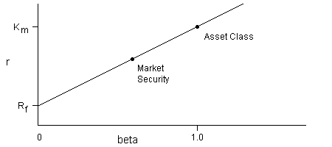
Naturally, somebody has to verify that this simple relationship actually holds true in the market. Part of the question is how few classes you can get away with: whether you can use a very coarse division into just "stocks" and "bonds", or whether you need to divide much further (into "domestic mid-cap value stocks", and so on). There are also ongoing attempts at "building better betas" that incorporate company debt and other traditional valuation measures, instead of relying solely on past volatility, to measure risk. All of this is a full-time job for academic modern portfolio theorists (and deriding the whole effort is a popular hobby for some traditional stock analysts: how could a magnificent company equal a mediocre one times beta? To them, CAPM seems like a very blunt instrument.)
CAPM has a lot of important consequences. For one thing it turns finding the efficient frontier into a doable task, because you only have to calculate the covariances of every pair of classes, instead of every pair of everything.
Another consequence is that CAPM implies that investing in individual stocks is pointless, because you can duplicate the reward and risk characteristics of any security just by using the right mix of cash with the appropriate asset class. This is why followers of MPT avoid stocks, and instead build portfolios out of low cost index funds.
(One point about that last paragraph. If you are trying to duplicate an expected return that's greater than that of the asset class, you have to hold "negative" cash, meaning you have to buy the index on margin. This is consistent with the big message of MPT - that trying to beat the index is inherently risky).

